SEAT OF LORE - OGHMA CHURCH BERDUSK
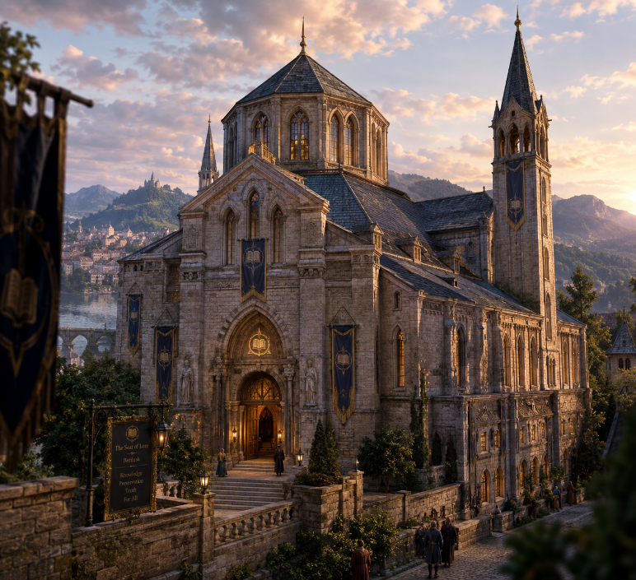
Official Name: The Seat of Lore
Common names: The Seat, Oghma’s Seat, The House of Binder and among scholar, simply “Berdusk”, referring to the temple’s library.

The Seat of Lore is an old stone house, dignified rather than spectacular, packed with books, maps, scrolls and reading tables, illuminated by magical driftglobes. Its specialty is history and contemporary stories rather than simply genealogies, laws and treaties.
By 1160 DR, the Seat has evolved. It is now one of the most respected regional repositories of historical and contemporary knowledge in the Western Heartlands.
THE PHILOSOPHY OF THE SEAT: The Seat teaches three principles.
1. Knowledge must be preserved. Obvious. A lost book is a loss to everyone.
2. Knowledge must be tested. A written statement is not automatically true merely because someone wrote it. The Seat compares: chronicles, diaries, songs, eyewitness accounts, religious texts, travelers' tales, inscriptions, genealogies, oral traditions.
3. Knowledge must not be owned by the powerful. The Seat does not believe that kings, churches, noble houses or wizards should possess the sole right to determine what history says.
A king's chronicle is evidence. So is a farmer's diary. So is a dead soldier's letter. So is a tavern song.
The question is: "What does it tell us?", instead of "Who wrote it?"
THE SEAT'S PHYSICAL LAYOUT:
1. The Hall of Reading: The public heart of the temple. Long tables. Reading lamps. Driftglobes floating beneath the ceiling. Copyists. Travelers. Scribes. Bards. Merchants checking old maps. Nobles researching ancestry. Adventurers looking for forgotten ruins. Priests researching obscure theology.
Anyone may enter.
2. The Hall of Voices: This is where contemporary information is gathered.
The Seat maintains: travelers' reports, caravan accounts, bardic stories, political rumors, ship reports, military news, reports from adventurers, accounts of strange phenomena.
This is the spiritual descendant of Bransuldyn's old practice of wandering disguised through Berdusk and the Vale to gather information.
The Seat has perhaps twenty to thirty regular informants throughout the region. They are not spies. Officially. They are simply: "People who have seen things worth remembering."
3. The Archive of First Copies: A more restricted library. Here the Seat stores the earliest or most reliable copies of important works.
Particular emphasis is placed on: original manuscripts, eyewitness accounts, old maps, religious writings, disputed histories, genealogical records, accounts of wars, treaties, records of vanished settlements.
A visitor can read much of it. But cannot copy it without permission.
That reflects the old Seat's practice of having its own clergy make copies while forbidding ordinary visitors from copying its holdings themselves.
4. The Room of Contradictions: A small circular chamber containing two or more contradictory accounts of the same event.
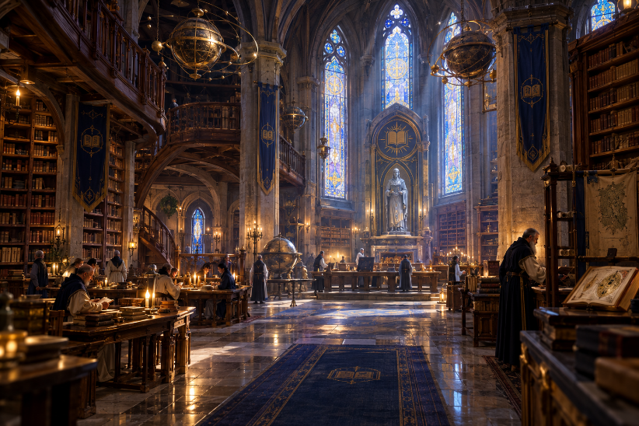
The Oghmanytes deliberately preserve both.
On a table might sit: The Battle of Black Oaks — Lord Harand's Chronicle beside The Battle of Black Oaks — Diary of Jessa Fen
The first says: "The army defeated the orcs decisively."
The second says: "We ran."
The Seat preserves both. Because someday someone may discover which one was lying.
This room is where your character developed his obsession with missing pieces and contradictory records.
5. The Lower Scriptorium: Here manuscripts are, repaired, copied, translated, authenticated, compared.
This is also where the Children of the Passive Voice have their local presence. Officially, the members are simply guardians and scholars. Unofficially, some of them are the people who know what lies beneath the Seat.
6. The Vault of Unresolved Lore: This is a vault of Books nobody understands.
Fragments. Half-translated inscriptions. Broken tablets. Anonymous manuscripts. Languages nobody has identified. Maps showing places that nobody can find. Accounts that contradict every known historical source. Books whose authors cannot be identified.
The Seat refuses to discard them. Because: "Not understood" is not the same thing as "false."
THE HEAD OF THE SEAT IN 1160 DR: Bransuldyn Mirrortor is the High Loremaster of the Seat. He is a gnome cleric, former adventurer, master of disguises, and enthusiastic gatherer of information. He is also very old, even by gnomish standards.
He has become less visible. The young clergy think he spends his days reading. They are wrong.
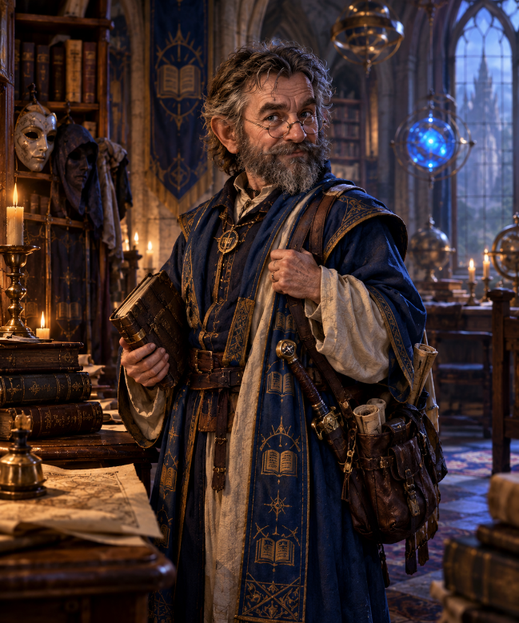
He still disappears from the temple for weeks. Nobody knows exactly where he goes. Sometimes he returns with a new book, or an obscure accent or a completely different set of clothes or a story about something that happened fifty miles away.
His old habit of disguising himself is legendary. He is a former adventurer who wandered Berdusk and the Vale disguised while gathering lore, using his own spells to record and transcribe what he heard.
He is very small, with silver-white hair and huge eyebrows. Usually wearing yellow-white Oghmanyte robes covered with pockets. He always carries three quills, two notebooks, spectacles, magnifying lenses, several pieces of chalk, a knife for scraping wax seals and at least one completely unnecessary key.
His beard is usually stained with ink. He frequently forgets where he put his hat. He does not forget anything else.
Bransuldyn is cheerful. Almost annoyingly so. He loves gossip, rumors, taverns, jokes, etc.
He has absolutely no patience for people who say: "Everyone knows that."
His immediate response is: "Then someone should have written it down."
He hates intellectual arrogance. He loves curious people. And he has one peculiar habit: He asks questions he already knows the answers to.
Not to test people. To discover how they answer.
His philosophy: Bransuldyn has one maxim: "Truth is not frightened by questions."
And another: "If a question is dangerous, ask why someone fears the answer."
BRANSULDYN AND YOU: Bransuldyn is personally responsible for recognizing the character's potential, because he sees a dangerous obsession.
When you were you, about 12 years old, you asked Bransuldyn: "How do we know this book is telling the truth?"
Bransuldyn answers: "We don't."
You were surprised. Bransuldyn smiled. "That's why we have another book."
Years later: "But what if both are wrong?"
Bransuldyn: "Then we find a third."
And eventually: "What if there is no third?"
Bransuldyn looks at you for a long moment. "Then you have just found the beginning of your career."
THE CHILDREN OF THE PASSIVE VOICE: The Children are a neutral Oghmanyte monastic order whose members protect libraries and abbeys and sometimes undertake missions to recover lost knowledge.
However, there is a secret internal tradition within them. A hidden discipline. It is called The Shielding Hand
Most outsiders never hear the name. Even most Oghmanytes don't know it exists.
THE SCHISM OF SECRETS: Centuries ago, the Redactors infiltrated libraries. The Children initially refused to interfere. They were observers. They recorded. They preserved. They did not judge political disputes.
But the Redactors discovered a terrible weakness: A neutral librarian can be defeated without ever being attacked.
You simply destroy the library. The Children realized that their passivity could become complicity.
That became the Schism of Secrets. There were no armies. No civil war. No dramatic rebellion. Instead, two philosophies emerged.
The traditionalists: "We preserve knowledge. We do not interfere with history."
The Shielding Hand: "If someone destroys the record before we preserve it, we have preserved nothing."
The second philosophy remained deliberately unofficial. The Church of Oghma could therefore continue truthfully saying: We sponsor no military or knightly orders.
The Children remained a monastic order. But within the order, certain monks began selecting outsiders with particular qualities.
THE SHIELD OF THE SCROLL: You are an Oghmanyte champion attached to the Children of the Passive Voice.
Your title: Shield of the Scroll
The title is never used publicly. It is spoken only within certain circles of the Children.
The Shield has three duties.
- Recover: Recover knowledge that has been stolen.
- Protect: Protect scholars, scribes, archivists and witnesses who cannot defend themselves.
- Prevent erasure: Stop anyone who seeks to deliberately destroy historical truth.
First Oath — The Quill: "I shall not destroy what I do not understand."
Second Oath — The Scroll: "I shall preserve what others cannot preserve for themselves."
Third Oath — The Shield: "When knowledge is threatened, I shall stand between it and the hand that would destroy it."
THE SECRET TEST: The Children do not recruit Shields openly. A senior member observes someone for years. They look for three qualities:
Curiosity: Does the person genuinely want to know?
Reverence: Does the person understand that knowledge is valuable even when it contradicts his beliefs?
Courage: Will the person actually defend it?
Your obviously possessed all three.
THE LEDGER OF GRACE CHANGED EVERYTHING: The Children could have considered the Tethyr mission a failure. Corvus escaped. The target escaped. You were burned, But you saved the Ledger.
The senior monk who reviewed the mission asked you: "Why didn't you pursue him?"
You answered: "Because I couldn't do both."
The monk: "And you chose the book."
You: "I chose the people whose names were in it."
The monk said nothing. Then: "You understand."
That was when you became a true Shield.
Asbravn was the event that nearly broke you, because this time he could not save the knowledge. You could not save the acolytes. You could not stop Corvus. And you lost manuscripts.
When you returned to Berdusk, you expected punishment. Instead Bransuldyn listened. You told him everything. When you finished, Bransuldyn asks: "Did you preserve anything?"
You said "No."
Bransuldyn shook his head. "You preserved a question."
You did not understand. Bransuldyn continued: "You know what was taken. You know who took it. You know what he was looking for. You know what he left behind."
Then: "That is knowledge too."
THE SECRET CELL BENEATH THE SEAT: That was your home. A tiny, old room beneath the scriptorium.
The official name is: The Chamber of Safekeeping. Only four people in Berdusk know it exists.
There are only 8 living Shields, active, as far as you know. 8 because the Children are terrified of creating another military order.
Most Shields never meet one another.
Initially, each is assigned a geographical region. One protects the northern libraries. One works around Cormyr and the Dalelands. One works around the Inner Sea. One operates along the Sword Coast. One specializes in ancient ruins. One specializes in religious texts.

